|  |  |  |  |
| --- | --- | --- | --- |
| Policy Number: | SS02 | Originator: | Nigel Troop |
| Issue Number: | 4 | Authoriser: | Kate Stradling |
| Issue Date: | 01/09/2024 | Service Type: | Education |
| Next Review Due: | 31/08/2025 | Policy Location: | Wessex Lodge School Policy File |

This policy explains the school approach to supporting behaviour in school. This policy should be read in conjunction with Wessex Lodge School Behaviour Policy and Anti-Bullying Policy.

# Aim

The aim of this document is to outline the strategies and techniques used by Wessex Lodge school. This policy is written as a reflection of the theory and strategies staff employ and are trained in. Staff receive intensive training upon induction (6-8 weeks) and at regular repeated intervals and daily repeaters. This document is aimed to explain to Parents/ careers/ linked professionals the wide range of Thrive practice that underpins the school’s Therapeutic approach to working with young people and helping their social and emotional development. The document therefore is lengthy but outlines the theory and related practices staff employ to attune to /engage and develop our young people and how they may work with triggered presentations. Alongside the therapeutic approaches (thrive practice) this document outlines the praise/ reward system, the action response ladder and the use of Outreach and home intervention work. It also includes the theory and impact of loss/ bereavement. Thus demonstrates the multi approach system employed to support and develop young people.

At Wessex Lodge School we provide ‘an Individualised Education to Improve Life Outcomes’. We work from a starting point that validates safety in relationship for learners and that behaviour is a communication of an unmet need. As a team, we now nurture resilience in learning, a move we made from behaviour management to emotional co-regulation. This policy is underpinned by Thrive Approach, which promotes adult-child relationship as vital work when developing social and emotional resilience for learners. This is achieved by offering all adults a range of information, activities, techniques and resources to nurture resilience and promote positive behaviour and attitudes.

When young people experience safety in relationship they open up to new opportunities; when they experience a threat to their safety, they mobilise themselves for responding to danger or prepare to shut down when the situation is overwhelming.

At Wessex Lodge School we promote 4 pillars for the school community from the acronym CARE

* Caring
* Adaptability
* Resilience
* Empathy

# Policy

* 1. Wessex Lodge School works with the Thrive Approach in order to meet each young person in their experience and reality. This means adults play a key role in supporting regulation. Adults roles include Co-regulator, Co-adventurer, Co constructor and facilitating individuality, experience to extend skills, Rock and resource. This is achieved by:
  2. Co-regulator - All young people need to have the experience of an adult providing them with a secure base and calming them when they are physiologically dysregulated. We describe this as meeting **Being** needs by being a co-regulator.
  3. Co-adventurer - All young people need to have experienced having secure adult bases to depart from to explore the world, while knowing they can retreat to this secure base in order to refuel, share experience and regulate in the face of danger or threat. We describe this as meeting **Doing** needs by being a co-adventurer.
  4. Co-constructor - All young people need adults who ‘lend their brains’ to help them make sense of the complex and often incoherent information all around them. Adults help to organise young people’s experiences, develop their capacity to reflect and support them to make mental representations of themselves in relationship with others and the world by holding the child’s mind in their mind and reflecting this back to the child. We describe this as meeting **Thinking** needs by being the co-constructor of meaning.
  5. Facilitating Individuality - All young people need adults to support their growth and understanding of self and to accept and celebrate their difference. We describe this as meeting needs in Power and Identity by Facilitating Individuality.
  6. Providing experiences to extend skills -All young people need adults who can support development of skills and understanding the need for structure and boundaries. We describe this as meeting needs in Skills and Structure by providing experiences to extend skills.
  7. Rock and Resource- All young people need adults to support their increasing gender identity and independence. We describe this as meeting the Interdependent needs by being a Rock and Resource.

All our young people at Wessex Lodge School have an entitlement to receive the highest possible standard of care and a broad, balanced and relevant curriculum that spans their whole day. Due to their placement with us, often because of the social, emotional and behavioural challenges that they face, it is essential that in seeking change our aims should be to:

* + - Work consistently with our young people to bring about social, emotional, behaviour and educational change
    - Measure the success and monitor and identify areas/ patterns of presentations to create change
    - Encourage a high level of academic and social success
    - Provide specific planning to allow individuals to succeed
    - Be in a position to provide feedback (PEP’s, Annual Reviews, Reports and academic monitoring) at regular intervals based on evidence
    - Base our work with our young people on their positive/ success rather than on a negative focus
    - Be in a position to accurately identify a student’s dis-regulated behaviour(s) in order to provide input to bring about change and success.

All of our young people should enjoy a quality of life (in school and at home) that recognises their rights as individuals improving life outcomes. School therefore aims to provide a stimulating environment in which we can address and work on individual’s needs, in order to equip them with the skills, knowledge and understanding that they will require to take their place in society as responsible citizens.

The system seeks to be flexible, in order to take into account the skill level of each individual young person and to provide a medium of consistency for both staff and students by managing and modifying presentations, by way of reinforcement, encouragement, motivation and by aiming to increase self-esteem.

* 1. **How do we build positive relationships (Relate-Rupture-Repair cycle).**

At Wessex Lodge School we recognise and focus upon social and emotional developments, before exploring academic growth. Positive relationship (peer on peer and young person to adult) are key to educational success. As a school we focus upon the changing needs of adults and young people but realise this can impact on their resilience and readiness for learning. At times these challenges can impact upon learning and can be displayed as trigger presentations. A break in connection between adult and young person is possible and likely when this occurs. Learning can come from this experience. We therefore promote the mantra that;

*‘MAKING UP IS MORE IMPORTANT THEN MESSING UP’*

We all make mistakes. Our focus remains on how we learn from this dynamic relationship (between peers and adults). Intervention work post-event, as part of the repair process helps student by giving them the opportunity to learn and relate to others around them. At times presentations may rupture these relationships, so as a school, we aim to help young people repair their relationships, enhancing the bonds and strength a young person’s social and emotional ability to maintain and uphold relationships in the future.

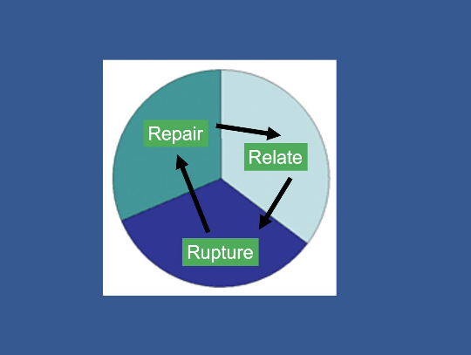

When examining each element of the Relate-Rupture-Repair cycle, we need to examine the specific skills we, as adults, can use to help support students with their interactions. We acknowledge that it’s ok to get things wrong because repair will happen. To define each part of the cycle;

RELATE – The time in relationship when we feel connected and attuned with one another.

RUPTURE – The times in relationships when there is misunderstanding or mis attunement; when we don’t get it right and we feel like the relationship experiences a setback.

REPAIR – Involves correcting the misunderstanding and mis-attunement of the rupture by trying to share understandings of intentions, feelings thoughts and actions in order to return to relationship relatedness. This is undertaken through intervention work with adults and may include other repaie work post trigger presentations.

When examining each element of the Relate- Rupture- Repair cycle, we need to examine the specific skills we as adults can use to help support students with their interactions. We acknowledge that it is ok to get things wrong because repair will happen. To define each part of the cycle;

* 1. **Techniques employed by staff.**

Our school believes that the therapeutic approach is needed when it comes to our young people attending the school. All staff are trained in the ‘Therapeutic Approach’, encompassing TIP and Thrive practice In addition, all staff are trained in Thrive techniques and practices. These work symbiotically together.

As a school, we recognise that every young person has a right to feel comfortable, safe, feel special and have their needs met. We encourage our young people to voice how they feel and what they need from us. Therefore, building relationships and connecting with our young people is really important to our school. This enables them to trust us, talk to us, and feel safe with us. When young people feel this they are able to access right time development and education.

To support the rhythm of the relationship cycle, staff use the stance of **P.A.C.E** and the communication skills of the **Vital Relational Functions** (VRFs).

**PACE** is an acronym used by psychologist Dan Hughes to describe the optimal adult stance when working with children to reduce stress, enhance connection. Through it use adults around the child promote safety and engender the learning with new social and emotional skills. PACE stands for;

* **Playfulness:** sensitive and appropriate playfulness helps the child feel safe and promotes positivity.
* **Acceptance**: unconditionally accepting the child for who they are, not what they do, makes them feel safe, secure and loved
* **Curiosity:** genuine and non-judgemental interest in the child helps them become aware of their inner life
* **Empathy:** demonstrating compassion for the child and their feelings supports the child’s sense of self-worth

All staff at Wessex lodge school will attempt PACE techniques to create the attunement with a student on a daily basis, but especially when trying to attune with a young person showing trigger presentations.

**VRFs- Vital relation functions.**

VRF represent the key techniques that we consciously apply in relationship. And represent the key ways of being with young people and each other. This starts from arrival but is especially key when a student shows trigger presentations and new staff step in as a change of face:

* **Attunement**: matching the energy of the child with non-verbal, prosodic, energetic and behavioural communication.
* **Validation**: acknowledging the validity of the feelings the child is experiencing
* **Containment**: predictability, routine and experiencing safety and security both relationally and environmentally
* **Regulation**: transforms what was too much to bear alone into an experience that can be tolerated together

Staff will use a variety of Thrive techniques to effect discussion/ change or management of presentations (these include P.A.C.E, VRF’s, WINGS and Sense-Feel-Stop-Think). This ensure they do not model aggressive behaviour. Aggressive presentations will be discouraged in a calm and well-measured style. Where there is danger to life (self/ peers/ adults/ animals) or risk of criminal damage, more direct techniques will be used (see below).

The Thrive approaches and action response ladder (below) should reduce the possibility of major issues occurring. Staff will firstly use therapeutic/Thrive approaches. Staff are also supported by and have direct access to the Inclusion & Engagement team (I and E) who can support, provide interventions or a change of face to help re-engage.

All young people have an Individual support plan (ISP) which staff have easy access to that outlines Thrive and EHCP targets, and the role of the adults when working with each child (dependant on Thrive stage) and the key hook information. In addition, it has the crisis model which outlines observed presentations, records the individual triggers, trigger presentations, preferred safe place and staff, key techniques most effective with that young person and what recovery presentation looks like. This remains a live document and is updated at regular intervals. This helps staff monitor and support our young people.

Some young people may at times seek direct confrontation. Such confrontation will be de-escalated skilfully by staff. As a school, physical interventions are a last resort method to therapeutic intervention techniques, unless there is direct threat to life or criminal damage.

**Shared responsibility.**

We believe that behaviours improve best where there is a shared agreement between young people, parents, and the school. Agreements are made on best approaches to be used. Each party involved must accept their responsibility and work together to achieve the desired outcome for the individual young person (welfare, education and social/ emotional development). We ask parents and carers to support this process with discussion and actions at home that reinforce Negotiable and non- Negotiable rules. When this relationship is broken, development is either slowed or halted and we normally see an increase in presentations.

When a young person is regularly displaying presentations which are inappropriate or challenging and which require strategies which are above and beyond those which are part of everyday classroom management and organisation, the young person will move up to stage 1 (or above) and have set an Individual Support Plan. It is expected that such behaviour will fall into one or more of the following categories:-

* Danger to self or others, either intentional or unintentional. Behaviour preventing access to learning.
* Disruptive behaviours in particular settings, making it unsafe for others. High frequency of unsafe behaviours.
* Refusal to work / disruptive behaviour, but not a danger to others
  1. **THE NURTURE-STRUCTURE HIGHWAY:**

Both Nurture and structure are crucial for healthy development of a child. However, where each is taken to the extreme, this can become detrimental. Remaining nurturing and structured depends on negotiable and non-negotiable rules which can empower both adults and young people to contribute to a safe and consistent approach to behaviour.

The Nurture-Structure Developmental highway model, developed by Jean Illsley Clarke, provides a way of helping adults consider the best possible support for the young person and how to avoid veering off into extremes.

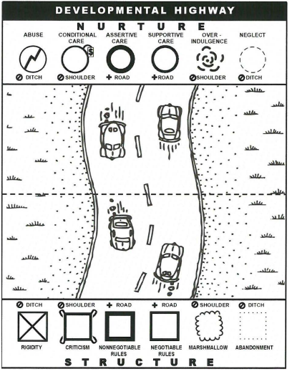

The metaphor of the highway serves to support the analogy of helping a young person stay steady in the middle of the road. This approach explores ‘therapeutic’ parenting as driving down the highway. When you stay in the centre lanes of the highway young people grow and thrive. To stay safe on the road you need a good set of front and back tyres – front tyres are the soft, nurturing side of parenting, back tyres are the firm, structured side. The best way to avoid overindulging young people or being too rigid is to avoid the shoulders and ditches. The middle of the highway is where the true power lies.

At Wessex Lodge School we maintain a stance of supportive and assertive care which promotes clear boundaries and a ‘let’s do it together’ attitude, allowing flexibility through negotiable rules and ensuring boundaries and structure through non-negotiable rules.

1. **HOW DO WE IMPLEMENT POSTIVE RELATIONSHIPS AT WESSEX LODGE SCHOOL?**

As stated previously in the policy, all staff receive induction training to Thrive approaches and how our community works with the relate-rupture-repair cycle, PACE, VRF’s and Nurture-Structure highway. All young people have an Individual support plan and receive Thrive reparative sessions (on average one per week) to support development gaps in social and emotional mental health. Spaces, resources and opportunities are provided across both sites of the school, to support student regulation and to prioritise engagement in learning. Wessex Lodge School acknowledges the barriers young people experience in coming to school and has a tri-pathway curriculum model to achieve readiness to learn.

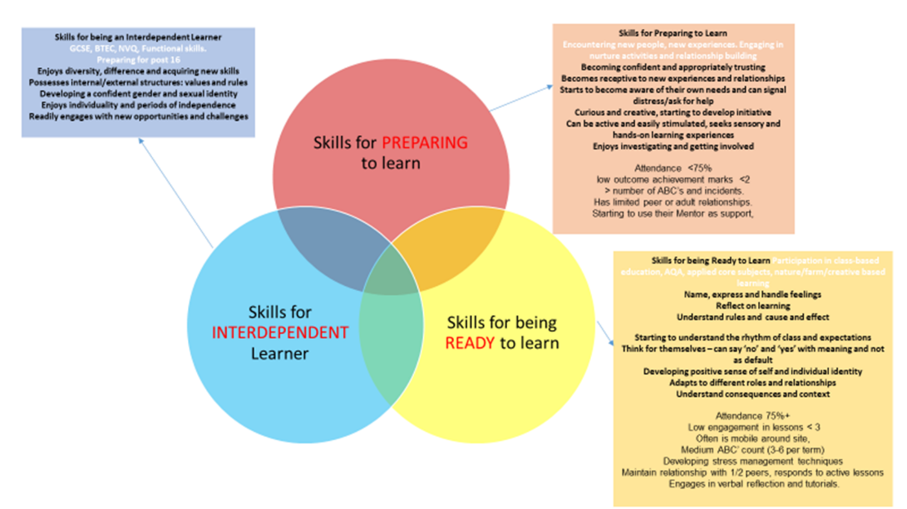

To support each young person wellbeing and mental health, Wessex Lodge School allocate a learning mentor/tutor to each child. The tutor’s role is to promote positive attachments and safety in relationship. Mentors meet and greet young people at the start and end of the day and provide check-ins across the school day if needed. Mentors are a go-to person for young people and adults. Wessex Lodge School shares daily information with parents and carers to ensure difficulties are discussed and addressed and positive engagement is celebrated.

Wessex Lodge School recognises that young people can come to the setting not yet able to recognise, manage or develop safety in relationship. To support with this the school has developed an Action-Response ladder which enables us to treat all young people fairly, although this may not be equally. Some children require more support to feel safe and learn to regulate than others and may require a range of interventions for this to happen. Learning about cause and effect is a key element of the Action-Response ladder.

Data in relation to student engagement, manifestation of arousal levels and incidents involving unsafe behaviours/ presentations are recorded daily on SLEUTH (electronic school system) to enable the school’s leadership team to monitor frequency, severity and to map progress, alongside the use of strategies and interventions used. Alongside this Thrive online is used to record progress in developing social and emotional resilience.

Student’s Individual Support Plans (ISP’s) highlight ways in which each young person can be hooked into learning through their interests. Reward systems can take an individualised form to meet the individual needs of students – these can be short-term (per lesson/per day), medium term (weekly or earning points for an end of term trip) or long term (accreditation/certification/qualification). Teachers and mentors will support each young person to engage in learning in a way which suits their learning style and to include incentives where needed and to meet their increasing resilience and interdependence.

Wessex Lodge School anticipates presentations that appear as bullying and promotes ‘non-negotiables’ approach to managing behaviours which can cause hurt and unsafe feelings or compromise child protection. Wessex Lodge School recognises the need for young people to feel hooked into the school experience and to be able to ‘negotiate’ in order to take ownership of their learning and to develop skills for life.

|  |  |
| --- | --- |
| **NEGOTIABLE** | **NON-NEGOTIABLE** |
| Reward systems will be individualised to suit learning needs and motivation of each student ie: - Short term – lesson activity based with reward time at the end: Medium term – collect a certain number of points for the week; Long term – earn points for end of term trip.  Strategies for regulation – what helps me to keep calm and regulated.  Key-working an animal – including animals as safe space.  Safe space/safe person – finding adults and spaces which help me when I’m anxious.  Activity choices (ie: choose from two maths worksheets)  Student council member ship promotes involvement of all students views around end of term celebrations, reward trips, some elements of environmental development (ie PE space), hook days.  Lunchtime activities  Lunch choices to suit personal taste and dietary/cultural needs.  Curriculum planning for Pathway 3 ie: ODE planning, subject choices for qualification. | Wessex Lodge School will address behaviours that are harmful and unsafe according to the developmental needs of those involved and in line with the individual students’ position on the Action-Response ladder.  Young people will give in all phones/tablets on arrival at school each day – these will be returned before leaving at 3pm  Young people will give in all smoking/vaping paraphernalia on arrival at school each day – these will be returned before leaving at 3pm  persistent Swearing, sexualised/racial/discriminatory comments  Refusing lessons and low engagement  Verbal abuse towards others  Disruption to others learning  Climbing gates and fences, climbing through windows and other unsafe behaviour.  Throwing objects to hurt others/damage property.  Harming animals.  Threat to life and to others wellbeing |

**3.2** **Losses in life & Learning and the impact upon norm presentations**:

Every year 20,000 children under the age of 16 years will be bereaved of a parent and many more will experience the death of someone else special in their life. In addition to these, individual pupils and or schools may also experience the death of a child at the school or a staff member. It is almost inevitable therefore, that at some time all schools will have to deal with a death that affects the school community. Death can also include the death of a family pet or for example a school animal (e.g.- horse, goat, etc…).

As children spend a large proportion of their time at school, teachers and staff members often become the primary source of care and support. Similar feelings of bereaved in children can also be triggered by the loss of a key staff member within the school community leaving.

Many students will therefore see our school as a safe haven away from the turmoil of emotions at home and will look to trusted staff members for help. Wessex Lodge School acknowledges that the emotional and physical impact of loss for young people present differently. Young people who have experienced multiple school placements, a range of adults coming into and then leaving their lives can impact upon their resilience level and result in low self-esteem and negative mindset. This in turn, can becomes a barrier to learning. Thrive approach emphasises the importance of understanding the chemical dynamic of the brain and the grief cycle. At these points/ moments in time, student presentations may be triggered. Intervention work will be undertaken to support this.

Where news of a death needs to be shared in school, parents will be informed in the first instance and agreement reached about who will inform the young person and when. This will ensure a child-centred approach from trusted adults. Where news of staff departure (a natural part of school life) needs to be shared, school will inform parents before, then sharing the news themselves. Wessex Lodge school acknowledges the need for many young people to have time to process this news. We promote adults who are leaving to support young people and each other through the relate-rupture-repair cycle to ensure everyone can maintain relationship during the lead up to the adult leaving.

There are interactions in the adolescent brain which can cause heightened responses to loss and grief. In addition, the interplay between feel-good chemicals and stress-related chemicals can cause erratic responses and difficulty regulating in times of stress:

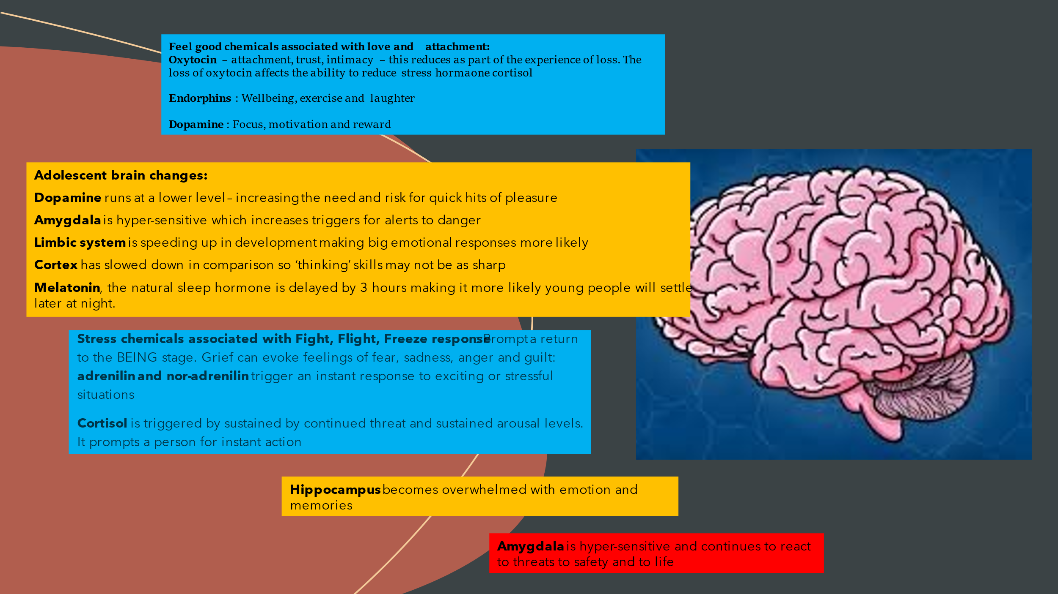

The tasks of grieving can be a dynamic process that is different for everyone. These tasks can take the following form:

* ACCEPTANCE
* FEELING
* ADJUSTMENT
* RE-INVESTMENT EMOTIONALLY IN RELATIONSHIPS
* INTEGRATING THE EXPERIENCE AS PART OF THEIR OWN NARRATIVE

As Therapeutic parents it is important to recognise the need for young people and each other to be able to ‘tell the story-tell the story-tell the story’, to be able to reach a point of integration of loss into our narrative. In the case of loss within the school community, the Leadership Team and staff Wellbeing team will ensure all staff receive regular check-in and offers of support to navigate the experience.

Guidance for Specific Incidents:

A). **SAFE TOUCH:** Wessex Lodge School recognises that some young people need and benefit from safe and containing touch to promote safety in relationship. This may include full or side hugs (where both parties are comfortable and attunement requires this) offering physical comfort for difficulties and/or pain and discomfort following accidents.

B). Where possible staff will offer/receive hugs and physical comfort with others around to observe. If this is not possible, staff will record the safe touch intervention as part of daily handover and will ensure they record preferred form of touch as a regulatory strategy on the student Individual Support Plan.

* 1. **EXAMPLES OF SCRIPTS AND RESPONSES USED**:

The Thrive Approach promotes consistency and repeated experiences in order to re-route or lay down pathways; supporting regulation and positive choice. The following scripted responses, in the form of the WING acronym, help Wessex Lodge staff offer support to young people in a non-confrontational manner:

**‘Wonder’** aloud what might be going on for a young person – ‘I’m wondering what’s going on for you’ or ‘I wonder if it would help to use the swing’

**‘Imagine’** into their experience and what might be happening – ‘I imagine that might be because you’re tired’ or ‘I can imagine that felt really hard’

**‘Notice’** the physical manifestation of their internal emotional landscape – ‘I can see that you are unhappy, you are angry and shouty’

**‘Guess’** what thoughts might be happening or what might help – ‘I guess it could be because’ or ‘I’m guessing a drink might help right now’

Some young people may discharge their thoughts and feelings in an unsafe way and may endanger themselves and others. Adults can respond to this with a phased approach to setting boundaries:

‘I am asking you to…’

‘I am telling you to…’

‘I am going to help you to…’

Wessex Lodge school ask staff to always remember to **‘Connect before you correct’.** When working with students showing triggered presentations, staff will use a mix of Pro-active, Active and reactive approaches.

**Proactive strategies** are those used within lessons as part of the daily routine and organisation, such as:-

* Talking to a young person in a calm and controlled manner, using his/her name first and a brief instruction.
* ‘First....then /now….next’ (using visuals and symbols where appropriate).
* Having favoured choice activities available in class.
* Having a member of staff assigned to the young person.
* Organisation of the classroom, e.g. distracting toys not accessible, positioning of young people in class.
* Advance warning of change of activity, e.g. count down; use of timer / music. Staff modelling appropriate behaviour.
* Praise for appropriate behaviour.
* Use of young person’s strengths and interests.
* Any person who comes into contact with a young person e.g. new staff are informed of what can happen and what strategies are in place to de-escalate situations to may occur.

**Active Strategies** are those which are used when a young person is displaying signs of trigger presentations and consists of strategies used to defuse or de-escalate situations:-

* Be aware of any warning signs that inappropriate behaviour may occur. Divert and distract by adding another activity or topic.
* Display calm body language. Talk low, slow and quietly.
* Use appropriate humour.
* Continue to remind of appropriate behaviour. Offer alternatives and options.
* Offer clear choices.
* Give clear directions for a young person to stop.
* Remind young people about rules and likely outcomes. Set clear enforcement limits.
* Catch young people being good; use praise. Calmly and quietly repeat instructions.
* ‘First....then ’ (using symbols) – first do required activity, and then receive favoured
* activity as reward.
* Remove young people away from trigger and remove trigger.
* Remove an audience or take vulnerable young people to a safer place.
* Use safe defensive measures, guiding the young person away if he/she is trying to make physical contact.
* Effect a ‘change of face’ with colleague(s)
* Ensure that colleagues know what is happening, and get help.

A well-chosen word, can sometimes avert an escalating crisis. When young people are becoming angry, there is no point in getting into an argument. Telling people to calm down can actually cause more anxiety. Pointing out what the young person has done wrong can make things worse. The only purpose in communicating with an angry person is to prevent further escalation. It is better to say nothing and take time to choose your words carefully than to say the wrong thing and provoke a further escalation.

**Reactive Interventions** are the strategies that will be used if a student’s presentation escalates into a crisis situation, and could include the following:

* Make the environment safe. Move furniture.
* Remove objects that can be used as weapons.
* Guide assertively – hold or restrain if absolutely necessary. Change member of staff as needed.
* Planned ignoring.
* In a firm tone, repeat instructions.
* Inform the young person of consequences of their actions. Remove students to a safe area.
* Allow student time and space to :- Process information and respond Physically recover
* Talk about the incident

# 4.1 Recording and Rating Behaviour.

Behaviour incidents are recorded and monitored on the sleuth platform enabling staff to plan supportive interventions where required.

**The Action Response Ladder.**

The most significant points of our action response ladder are:

* + - Staff should focus on the young person’s observed presentations and be aware that these responses can also be unlearned.
    - Nearly all presentations are the result of learning or are a form of communication. The key person/mentor, the I&E team and our Thrive practitioners will work with individual young people to implement strategies that encourage young people to learn positive behaviours and unlearn unhelpful behaviours.
    - Behavioural/action change need to be measured. Measurements enable us to be more precise and objective in estimating and measuring developments.
    - Young people can learn on the basis of repeating actions that have been reinforced or rewarded. This is the basis of our behaviour management system.
    - We plan programmes and activities that allow maximum opportunities for the student to achieve targets (EHCP, Thrive and behaviour focuses).
    - We “Catch young people being good” and reward positive behaviours.
    - As staff we analyse and decode behaviour action communication in an attempt to facilitate change.

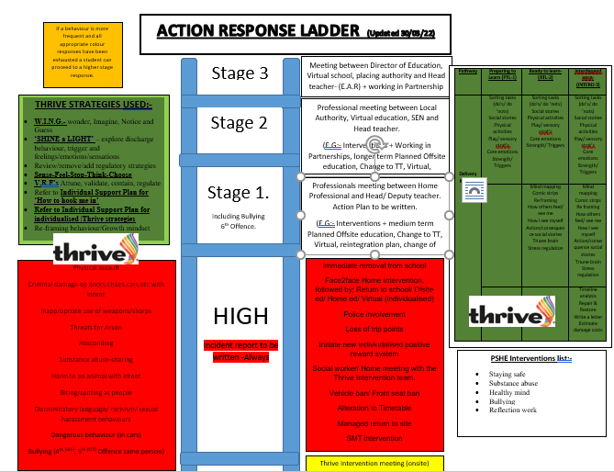

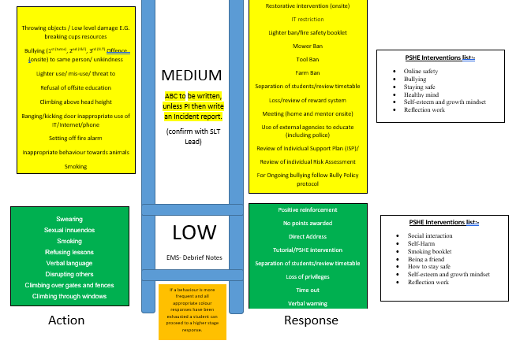

# 4.3 Agreed consequences:-

Wessex Lodge make every effort to focus on improvements and developments young people have made. When applying actions to unhelpful presentations, these actions are applied calmly, firmly and consistently and fit with the behaviour ladder. Within school, when presentations arise, staff will challenge or give quiet, private reminders as to our expectations. These are often most effective, although we recognise the need to ensure that the child in question is not ‘rewarded’ for unhelpful choices. The school consequences will not include humiliation, sarcasm or being forced physically to comply. Important features of Actions include:

* a focus upon unhelpful behaviour rather than the child. e.g. “that was an unkind thing to do” rather than “you are a very unkind girl”;
* a message about what the child should do in the future;
* *timing immediately after the misbehaviour;
* Actions appropriate to the unhelpful behaviour;
* looking for the possibility of praise after the punishment, to encourage positive behaviour development.

The action response ladder is on display and available for young people during tutorials and the presentations and the consequence are discussed with them using the chart. This work is primarily undertaken by the tutor/key worker first, but may then also include the I&E team, Thrive practitioner or SLT (site lead), dependant on severity or the number or repeated presentations. It is recognised that young people with Trauma or SEN needs require multiple opportunities to hear and understand the non-negotiable rules to assimilate to the message.

# Risk Assessments

Any young person that displays regular medium or high-level presentations on the Action response ladder will Require an Individual Risk assessment. This will consider the identification of any activities or environments that are associated with risk, establish the likelihood of risk for an individual young person or young people, estimate the consequences of an unhelpful outcome and take steps to avoid unreasonable risk. Risk assessment should contain all relevant information and be regularly reviewed. In order to preserve the dignity and promote positive community presence of young people, staff must act to ensure that all reasonable measures are in place to reduce the risk of young people displaying challenging behaviour in public settings. Staff must carry identification with them when supporting young people in community settings and be prepared to explain, or otherwise communicate, the necessity of their actions.

Risk Assessments will be shared and discussed with parents / carers, at Parents’ Evening and Annual Review meetings, and some strategies may require parental support, e.g. young person being told that his/her parents will be called to take him/ her home once his/her presentations reach an agreed level. Where a young person’s presentations are considered to be unduly disruptive to others or causing distress to the student or themselves, regular withdrawal with either Outreach (community based or alternative) or home education will be used.

# Positive Handling and Physical Intervention

# The school ensures that the appropriate departments within Children’s Services, parents / carers and potential young people are made aware of the school’s policy on the physical management of young people. This is discussed with parents / carers and potential young people at interview where the reasons for and the methods used to physically manage behaviour can be demonstrated. This should ensure that all concerned have a clear understanding of the school’s approaches, and should the physical management of a young person be required, or if a young person witnesses the restrictive physical management of another young person then the method used should not come as a shock to him/her.

# Intervention – Home/ outreach and virtual.

# Interventions are the delivery tool to help a child reflect and learn (social and emotional) from an event. This Thrive approach is called shining the light and is more tricky. It can only be undertaken if the connection is made. Intervention may be PSHE focused (e.g. staying safe, Healthy mind, Bulllying,self esteem, growth mindset etc…) or may be reflection and reparative work. The delivery method may vary and includes activities suited to the learning. On the action response ladder- any low or medium level responses will be undertaken in school first by the tutor, 2nd by the I&E team, and 3rdly by SLT. In this way student have multiple chances to reflect and develop before more impactful measures are taken. Any Actions in the high level or from frequent repeated medium and low level actions may result in removal from school/ home collection, police involvement, loss of points, social worker/ Thrive team meeting, Bans, altered time tables, Longer term planned outreach (6-12 weeks) or Home education. Home education can be delivered either virtually (via Teams) or face to face.

# In cases where presentations/actions are not changed or learnt from, intervention outreach is a method used to create a circuit breaker for presentations in school. Staff will collect your child around 10am and head out into the community away from school. There they will undertake reflective (shine the light) intervention work. This may include worksheets, videos, kinetics sorts, etc.. (see full list on Action response ladder). When complete they will undertake a physical activity and when settled some core work (English and Maths). Students will be returned to the home for 2pm.

# Home intervention is used by the school to reconnect with the child and the parent. It is used as a circuit breaker method when either we have received high presentations or repeated presentations which have not changed after in school intervention work (1st by the tutor/ key

# worker, 2nd by the thrive practitioner or I&E team, and 3rd by SLT). All of these interventions are recorded and may include videos, worksheets, discussion, etc..(see approaches on Action response ladder). Home intervention will be run by either lead I & E team, Lead Thrive practitioner or SLT. The next step is to re establish the triangle of support (Child/ Parent/ School). In this visit we will undertake reflective work (THRIVE - Shine the light) unpicking the presentations and setting new behaviour actions and expectations. This may use a variety of resources. We require home support and engagement with this conversation and the level of severity this now presents. It maybe, that if a child is presenting shameful, we may undertake the work 1:1 and then feedback with the parent/carer/adult after showing the working and talking between adults. Around this visit the school will offer virtual learning or home pack work. We ask that parents are fully supportive of these conversations and set aside methods that promote renewed development around the presentations within school.

# Should a student refuse or not engage in either intervention work, a repeat the next day will be set. Should this roll over multiple days a meeting will be set with Parents and young people with the Headteacher, in which the focus will be on the non-negotiable expectations.

# Exclusion-

# Wessex Lodge School do use fixed term exclusions. At all costs the school wish to avoid the use of this. The use of Exclusion jeopardises the placement of the child’s education with us, and the onward report can impact upon the acceptance of any future placements. The school aim is an individualised curriculum to improve life outcomes. The school will use strategies listed in the action response ladder that include long term Community or Alternative Outreach (6-12 week programmes), virtual education, home education or in partnership work first (stage 1 & 2). However, when the series of interventions available have been exhausted or the number of chances to adapt and adjust have failed (e.g bullying-6), or if a child has presented a series threat to life (self or others) or high level of criminal damage, or if home/parents fail to support Home intervention/home education/outreach education or virtual education then Fixed term exclusions will be used and reported to the Local Authorities. The school only have a fixed number of days allowed to exclude any one student before being forced to revoke placement. It is imperative that families/homes/parents work with the school and its Policies to support development and growth around triggered presentations.

# Links with other Policies

This policy links to the following policies and procedures:

* Staff code of Conduct * Complaints

* Attendance

* Online safety

* Sex and relationship education * Curriculum

* Mobile Phone Policy * Thrive Policy

* Positive Handling Policy * Anti-Bullying Policy

# Equality Impact Statement

All relevant persons are required to comply with this policy and must demonstrate sensitivity and competence in relation to diversity in race, faith, age, gender, disability and sexual orientation. If you, or any other groups, believe you are disadvantaged by this policy please contact the Regional Director. Acorn Education and Care will then actively respond to the enquiry.

This policy is written by Nigel Troop Date: 01/09/2024

Signed: 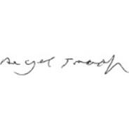

This policy is quality assured by Kate Stradling, Head Teacher

Signed:    
 Date: 01/09/2024